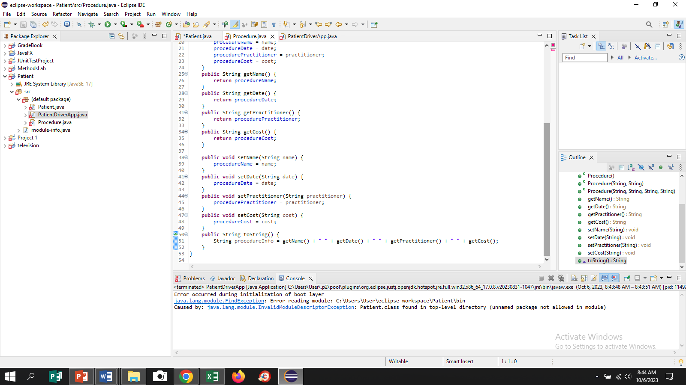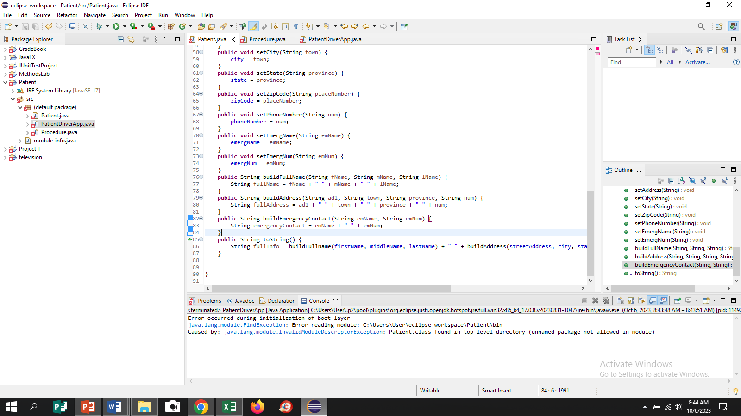

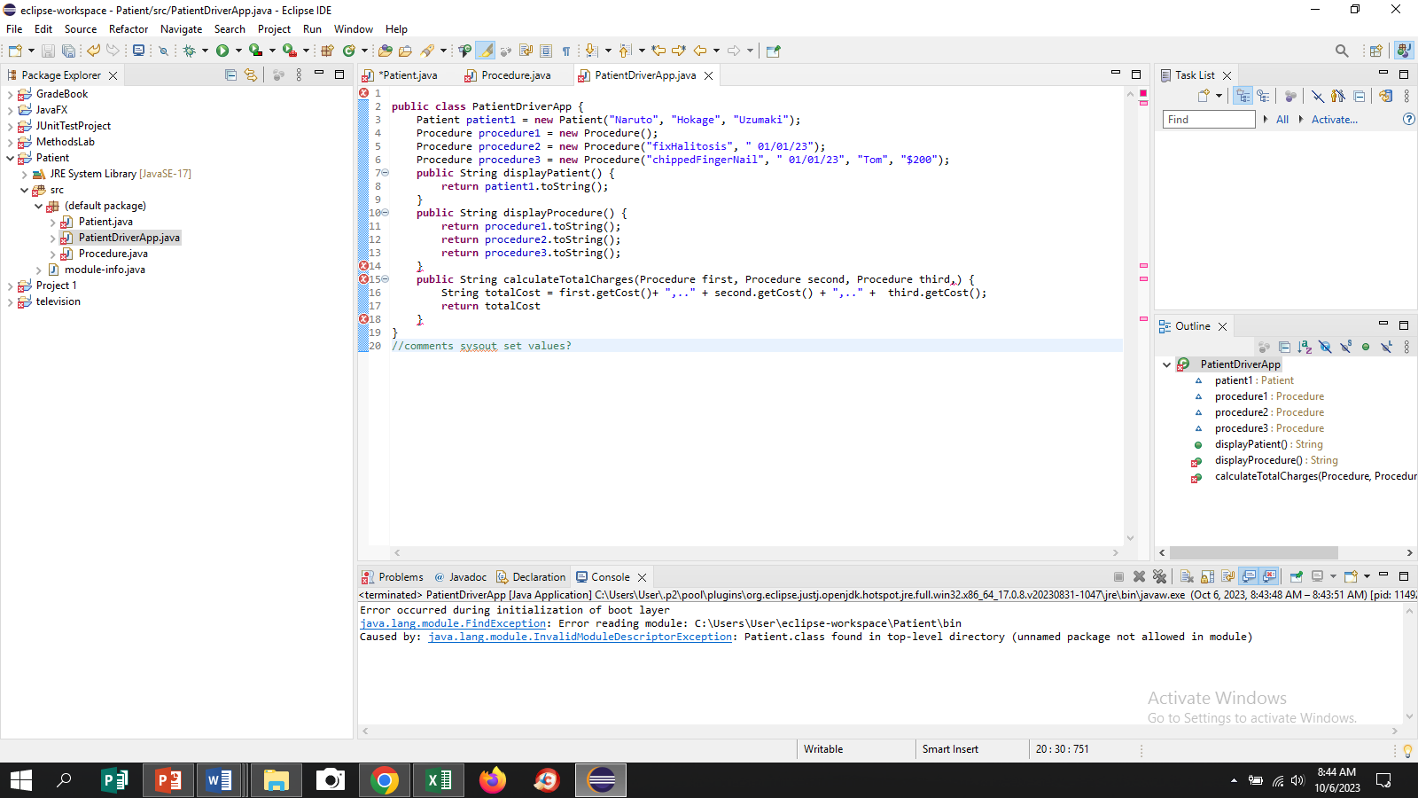

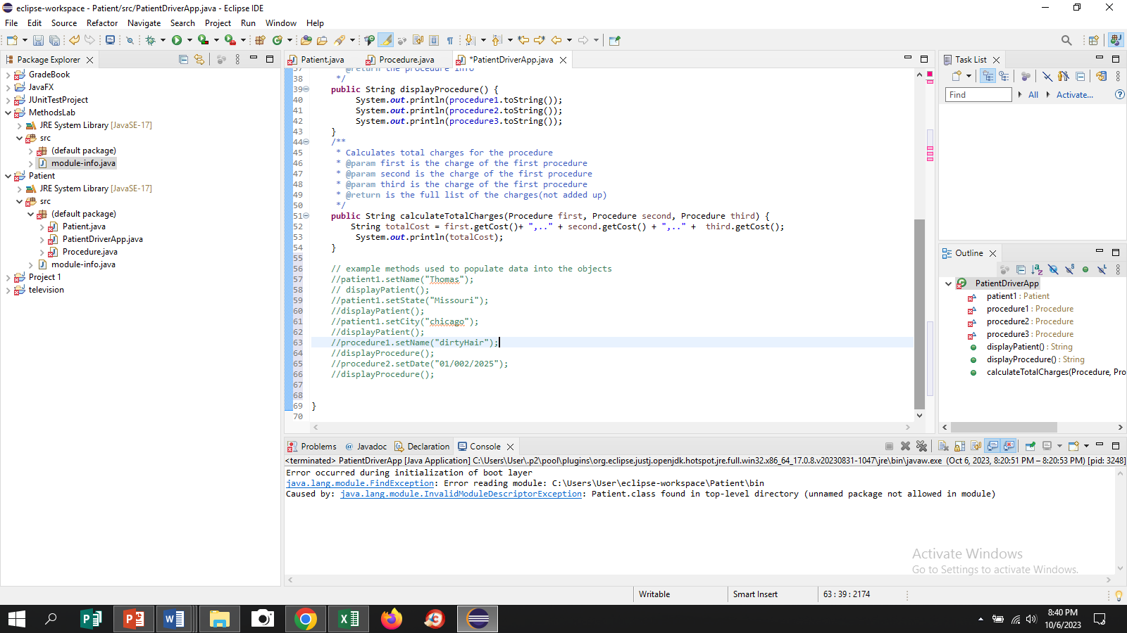

(Shows some test examples above)

(Screenshots taken before added javadoc comments.)

Test Plan:

|  |  |  |  |  |  |
| --- | --- | --- | --- | --- | --- |
| **Test Case #** | **Input** |  | **Expected Output** | **Actual Output** | **Did the test pass?** |
| 3Patient Diver Class | Objects set to run display methods, only uses no-arg constructors |  | Should display everything from previous classes | Displayed everything  except procedurePractitioner and procedureCost | Almost |
| 3Patient Diver Class | Objects set to run display methods, only uses arg constructors |  | Should display everything from previous classes | Displayed everything | Yes |
| 3Patient Diver Class | Objects set to run display methods,  Uses mixture of constructors |  | Should display everything from previous classes | Displayed everything without procedureDate and  procedurePractitioner | Almost |
|  |  |  |  |  |  |

UML Diagram for Patient Class

-----------------------------------------

**-** firstName: String

**-** middleName: String

**-** lastName: String

**-** streetAddress: String

**-** city: String

**-** state: String

**-** zipCode: String

**-** phoneNumber: String

**-** emergName: String

**-** emergNum: String

**+**Patient():void

**+**Patient(String, String, String):void

+getAddress():String

+getCity():String

+getState():String

+getZipCode():String

+getPhoneNumber():String

+getEmergName():String

+getEmergNum():String

+setAddress(String):void

+setCity(String):void

+setState(String):void

+setZipCode(String):void

+setPhoneNumber(String):void

+setEmergName(String):void

+setEmergNum(String):void

+buildFullName(String, String, String):String

+buildAddress(String, String, String, String):String

+buildEmergency Contact (String, String, String):String

+toString:String

UML Diagram for Procedure

-procedureName:String

-procedureDate:String

-procedurePractitioner:String

-procedureCost:String

+Procedure():void

+Procedure(String, String):void

+Procedure(String, String, String, String):void

+getName():String

+getDate():String

+getPractitioner():String

+getCost(String):String

+setName(String):void

+setDate(String):void

+setPractitioner(String):void

+setCost(String):void

UML Diagram for PatientDriverClass

(Objects)

+Patient(String, String, String):Patient

+Procedure():Procedure

+Procedure(String, String):Procedure

+Procedure(String, String, String, String):Procedure

+displayPatient():String

+displayProcedure():String

+calculateTotalCharges():String

Lessons Learned:

1. Lessons that I’ve learned while working on this project include the qualities of the work flow life cycle, the system for testing, and the quality of being detail-oriented. Some highlights were of just making sure to follow the instructions and making sure that the different parts fit together to keep the program together
2. I learned these things because of the different tasks needed while making the program, like seeing that typos do not occur, and that the program needs to be reedited and re-examined to be cleaned up and make more efficient
3. I struggled a bit with making sure the .tostring method flowed, but I simply looked it over and checked that it was receiving from somewhere and had something to do when called